WESTERN REGIONAL CENTRE
Plant Tissue Culture Laboratory
Plant Tissue Culture Laboratory of the centre was established in the year 2018 by with partial financial assistance from DST-SERB, New Delhi. The lab caters to various scientific researches related to species multiplication for conservation and restoration of threatened species, with current prime focus on Pteridophytes of Western Ghats. It also facilitates hands on training in tissue culture techniques to academic students, research scholars and individual researchers, where they are exposed to various instruments and technical approaches, related to the tissue culture such as aspects of species selection, collection of samples (spores), sterilization techniques, and cultures (spore and callus culture), etc. The lab comprises sterilization, Inoculation and Incubation chambers and culture rooms well-equipped with modern instruments.

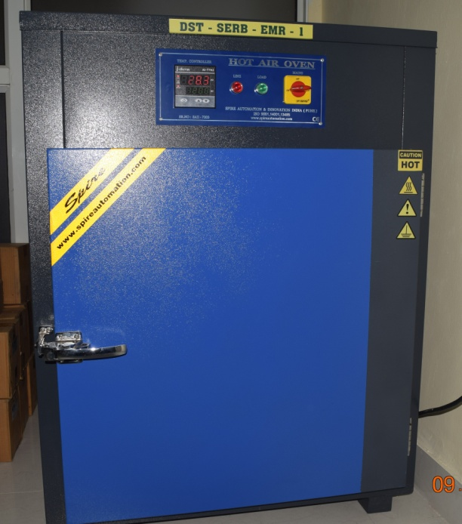
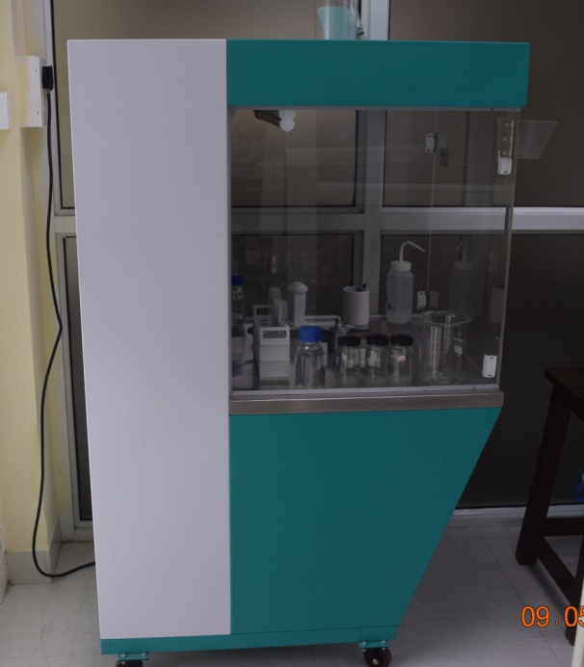

IN VITRO CONSERVATION OF SOME RET SPECIES INITIATED IN THE LAB
1. Cyathea nilgiriensis Holttum (Cyatheaceae)
There are eleven species of Cyathea occur in India of which C. nilgirensis is endemic to Western Ghats, India. The species is threatened and also listed in the Red Data Book. Being tree fern and endemic status, the species is academically very significant; therefore steps have taken to conserve and restore this tree fern.
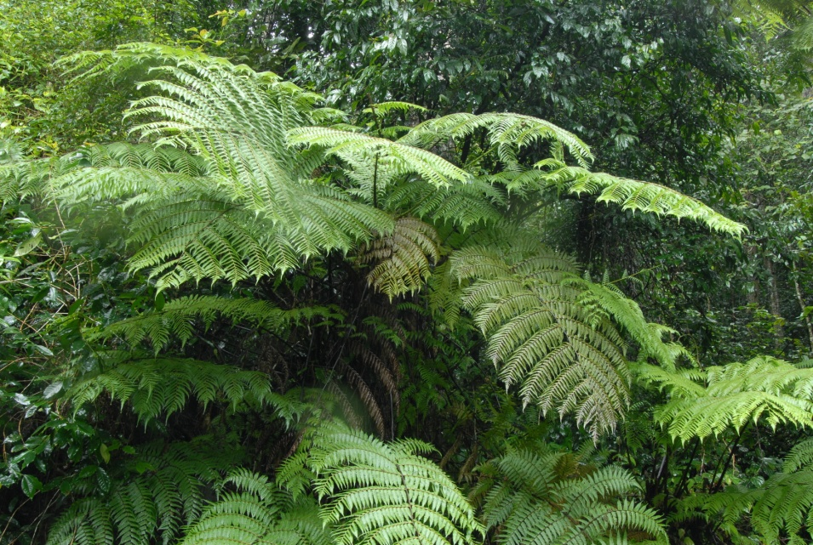
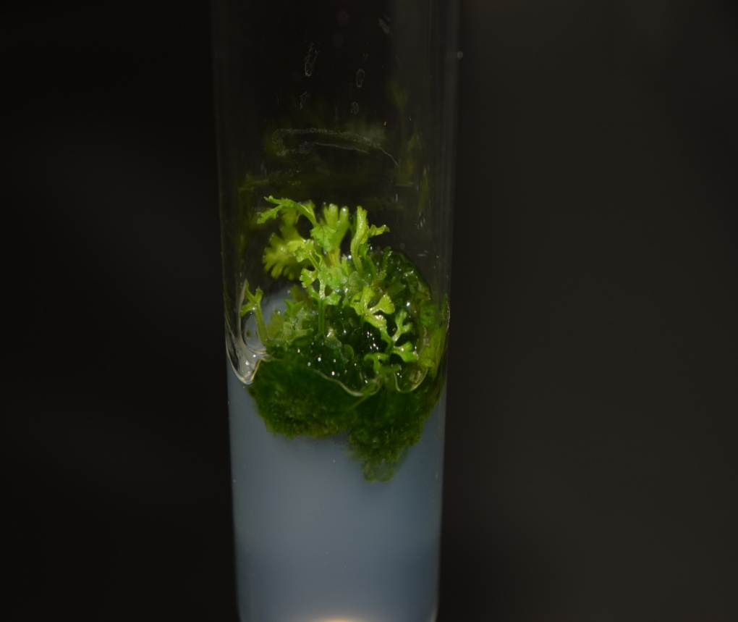
2. Anogramma reichsteinii Fras.jenk. (Pteridaceae)
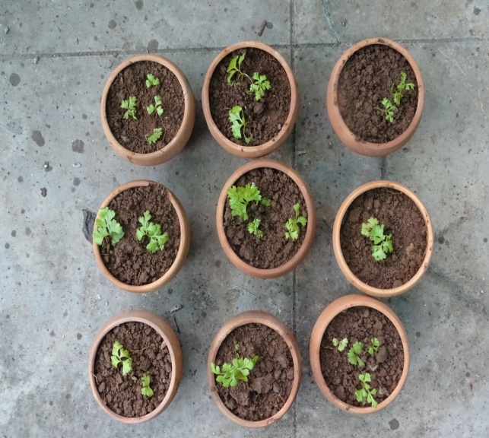
A. reichsteinii Fras.jenk. is now under threatened status and listed in the IUCN Red List Categories and criteria. During a survey in Chikmagalur district in Karnataka, this taxon has been collected from only two localities in a particular niche in Mullangiri hills (1930 m) with a population of fewer than 15 individuals and Bababudhan hills (1350 m) with a population of few than 10 individuals. In the Western Ghats, it is on the verge of extinction. Taking into consideration the occurrence of the population and its increasing tendency on the one hand and its threatened status on the other, our lap taken the steps to conserve this endangered ferns through in vitro propagation.
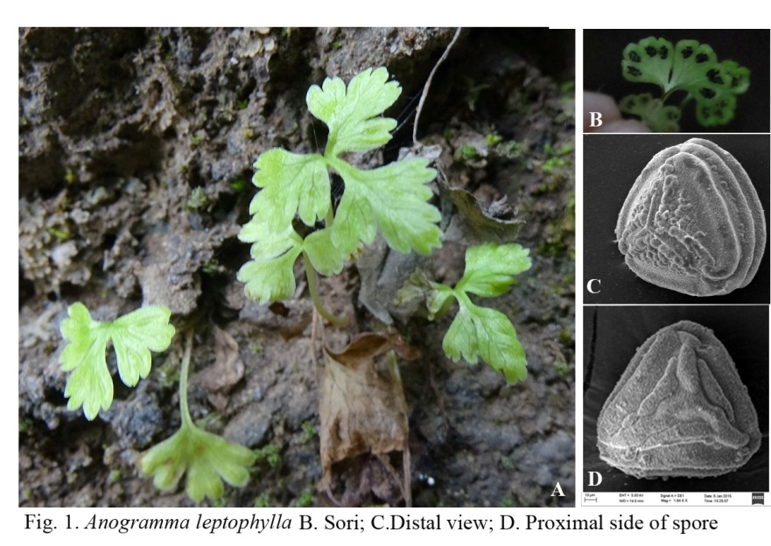
Ex- Situ Conservation of Anogramma reichsteinii Fras.jenk.
Anogramma reichsteinii Fras.jenk.
3. Diplazium travancoricum Bedd. (Athyriaceae)
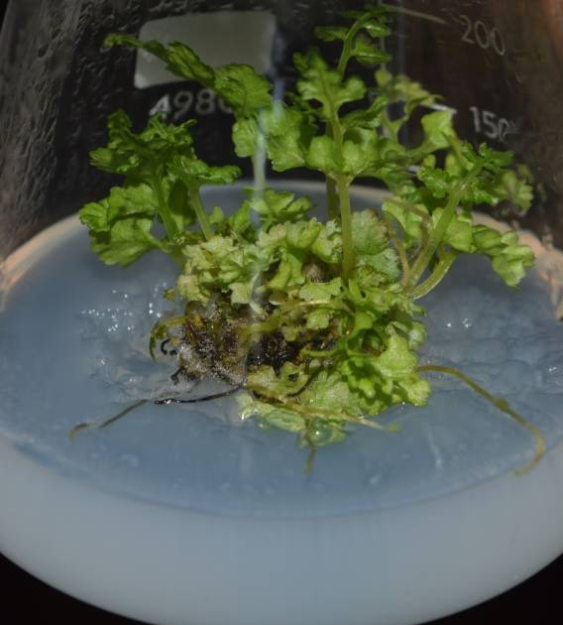
D. travancoricum is one of the rare and endemic ferns from Western Ghats of India. our lab has investigated to develop an efficient protocol for rapid multiplication of Diplazium travancoricum through tissue culture techniques.
Spore culture of D.travancorium Bedd.
In vitro raised fern D.travancorium Bedd.

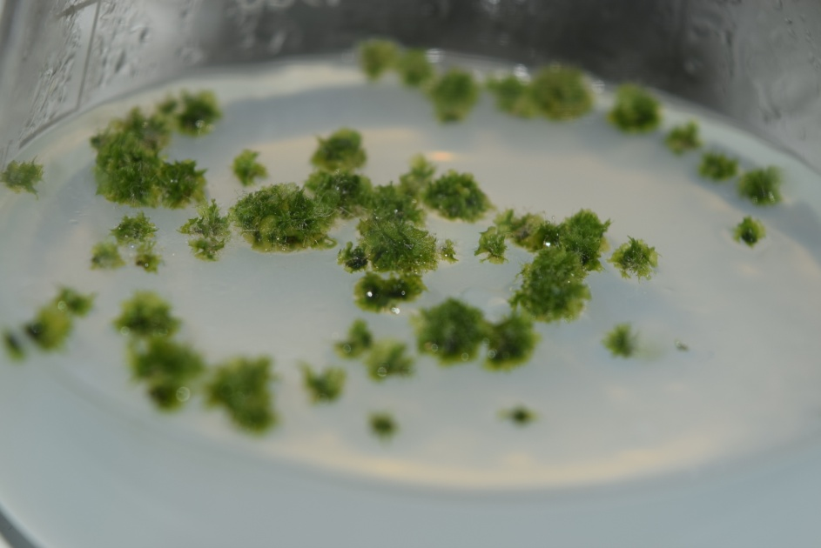
Ex-situ conservation on Ferns
Apart from the in vitro conservation we have undertaken the steps to conserve the RET species by rearing the live plant specimen in green house of the BSI, WRC Pune. At present there are more than 15 rare and 3 endemic species growing in the green house.
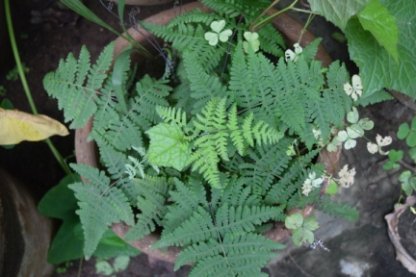
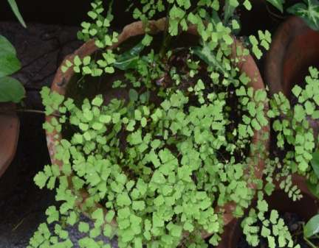
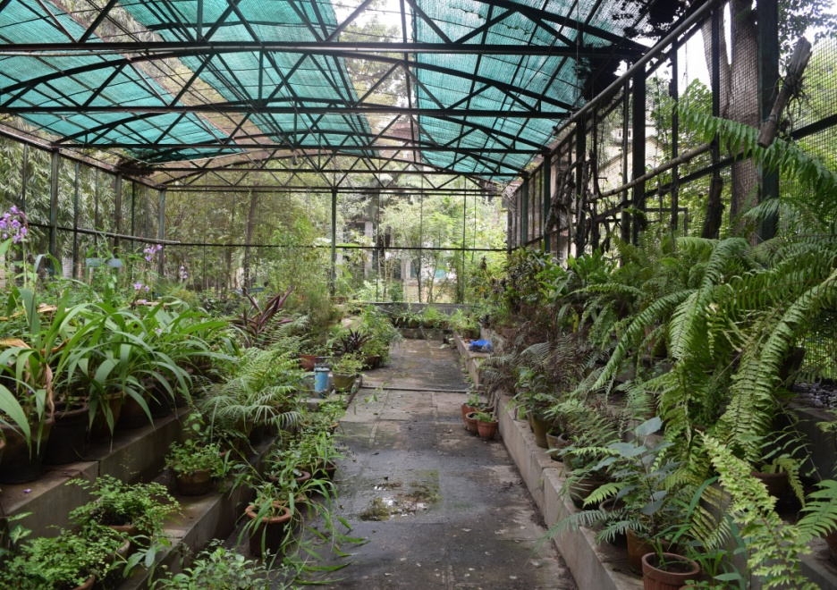
Green House WRC,Pune

Acknolwedgements
Thanks to Ministry of Environment, Forest and Climate Change, New Delhi, and Department of Science and Technology, New Delhi. Sincerely thanks to Director, Botanical Survey of India for giving permission to establish Plant Tissue Culture Lab at Pune. Thanks to Scientist E & Head for giving full support and encouragement during the work.

Dr. A. Benniamin
Scientist ‘E ‘
Botanical Survey of India
Western Regional Centre,
Pune

